Mental Skills Training For Combat Sports

Erin Herle

Master of Sport and Performance Psychology, University of Western States
COUN 6230: Psychological Preparation and Mental Skills Training
Dr. Vince Lodato
September 16, 2022

Table of Contents
Chapter One: Athletic Identity.........................................................................................................3
Chapter Two: Creating Performance Routines................................................................................6
Chapter Three: Self-Talk………………........................................................................................10
Chapter Four: Goal Setting & Goal Implementation.....................................................................15
Chapter Five: Mental Toughness……...........................................................................................22
Chapter Six: Focus, Concentration, & Managing Distraction.......................................................25
Chapter Seven: Imagery & Visualization......................................................................................30
Chapter Eight: Performance States……........................................................................................34
Chapter Nine: Stress, Emotion Regulation, & Handling Errors and Setbacks..............................38
Chapter Ten: Technology & Tools for MST………………..........................................................41
References......................................................................................................................................44
Mental Skills Training for Combat Sports
Chapter One: Athletic Identity
Combat sports athletes are unique. We dig deep, aim for positive outcomes, maintain composure, and face challenges with excitement. Who we are as combat sports athletes or athletes in general can be described as our athletic identity. It is the amount that an athlete identifies with their athletic role (Giannone et al., 2017). It is unique from other roles in that sport provides a platform for a person to achieve excellence. Whether your goal is to become the best MMA fighter in the world or to feel that you can safely defend yourself, defining the athletic role is a foundational tool for learning mental skills. As much as training combat sports transcends into our personal lives, balance is key. How can we be all that we want to be as an athlete while still maintaining progress in our other life roles?
What is Athletic Identity?
To define athletic identity, start by analyzing personality traits and needs. Identity is tied into how we define ourselves so understanding our athletic identity gives insight into many important factors like what mental skills might work for each situation and how to implement them into your game (Weinberg & Gould, 2019). The more aspects of personality are revealed, the more specific a mental skills training program will be. Beyond defining the athletic identity, it is important to develop one that is healthy and creates an enjoyable and successful experience in sport.
Healthy Versus Unhealthy
The difference between a healthy and unhealthy athletic identity is determined by if/how the role monopolizes you to the point of detriment. An athlete with a healthy athletic identity finds motivation to achieve excellence through this athletic role but maintains balance with other life goals. Motivation is found from within (e.g., passion) more so than from external factors. Focus is placed on athletic excellence or being the best you can be and mastery of the goals along the way. Motivation that is focused on the task rather than the outcome provides personal standards to compare oneself to instead of comparison to others (Weinberg & Gould, 2019). Combat sports athletes with healthy athletic identities recognize that sport requires sacrifice, especially at elite levels, so the sacrifice should be embraced but not to the point of a negative return on investment so to speak.
An unhealthy athletic identity can lead to negative outcomes like overtraining, burnout, shame/guilt, and injury. Athletes who have low self-esteem and feel pressure to conform to norms are likely to overconform to these norms called sport ethic (Hughes & Coakley, 1991). An athlete with an unhealthy athletic identity pulls from extrinsic motivational factors like social stature and material rewards (e.g., sponsorships). They use social norms as standards for evaluating themselves, placing their focus on the outcome of win or lose. This can cause athletes to deviate to harmful means of success (e.g., doping). Sometimes an unhealthy athletic identity may pull from intrinsic motivation like a sense of honor and duty to the team or sport but is still focused on outcome rather than excellence (Giannone et al., 2017).
Healthy motivation that stems from intrinsic stimulus pulls from three basic psychological needs: autonomy, competence, and relatedness (Weinberg & Gould, 2019). This is called Self-Determination Theory. Autonomy is the feeling that you are in charge of your choices and you have the ability to do what is best for you. Competence is being good at something and relatedness is feeling that you have a strong connection with others. When these three factors are satisfied and supported, excellence can be achieved in a manner that supports physical and mental well-being without unnecessary sacrifice.
Why is it Important?
It is important to keep your identity in mind because it lies at the core of your self-concept. Understanding your athletic identity is the foundation to building mental skills that will bring you closer to excellence. Once you develop and define your athletic identity, the real work can begin. Mental skills are the building blocks for psychological performance enhancement. As much as combat sports rely on physical techniques and strategies, the mental game is key to managing emotions in critical moments, dealing with adversity during a match as well as dealing with inevitable losses, executing strategies without hesitation, and much more. The mental fortitude gained by mental skills training is necessary for the fighting realm.

Chapter Two: Creating Performance Routines
Do you have a certain song you like to listen to before training or competition? Is there a specific warm-up you do every time you compete? Do you bow when you enter or exit the mat area? These are all examples of routines that we have to help us feel ready and in the zone. We don’t want to simply show up, we want to arrive. Combat sports are unique in their unpredictability. There are many variables that we cannot control but there are many that we can, so we will focus on what we can control regarding our performance. You may not be able to control what your opponent decides to do, but you can always choose how you respond. Whatever the task may be, performance routines help to heighten awareness and build confidence in your ability to succeed. What’s your mental plan?
Importance of Routines
Another word for routine is procedure so developing a mental preparation routine or plan is the process of deciding how you want to consistently approach, execute, and learn from your performance. This separates routines into a sequence of pre-performance, during performance, and post-performance. All together, you have a string of routines that lead you from start to finish. For example, when you arrive at a competition you can use the doors of the venue as a symbolic change in focus. As you pass through the entrance, use it as a cue to get into the zone by mentally preparing for the performance that is to come. Having the right mindset is crucial for fight time. Once in the venue, the process can look like: warming up, waiting for your name to be called, stepping on the mat or in the ring, executing the match or fight, and later reflecting on the performance. Knowing what to expect and how you will handle each step of the way reduces anxiety and increases self-efficacy (Hazell et al., 2014).

Types of Routines
Routines provide stability and familiarity despite changing environments. They are repeatable, consistent, and purposeful, yet flexible when needed (Lodato, 2016). Some people use superstitions or rituals to get in the right headspace but they are not reliable. Superstitions are not based on fact and are false beliefs. Rituals are similar to routines in that they provide that stability and familiarity but they have no real grounded purpose. Routines bring it all together in terms of preparation, consistency, and evidence-based practice.
What happens when the mental plan goes wrong, gets interrupted, or cannot be used? You must prepare with different types of routines. Combat sports have many variables and expose athletes to high emotional loads as well as possibility of injury (Andrade et al., 2021). Remaining focused, composed, and confident can be difficult when your opponent is ruthless. Depending on the discipline, there are many rule sets and circumstances under which athletes compete under so it is crucial to plan for as many “what if” situations as possible.
You can plan your routines as A, B, and C (Lodato, 2016). The first performance routine is considered your “A routine” because it is your ideal plan. This is the bare bones of your routines using things you can control no matter the environment. Things like changing into your uniform or fight gear, waiting for your name to be called, walking to the mat or ring, etc., are all expected. Your “B routine” is your “what if'' or plan b. What happens when you warm up but your division is running late? What happens when your opponent drops out? What happens when you receive an injury but still have to compete? These are all covered in your plan b as ways to adapt. Warm ups will not always be timed well before your performance even though you planned ahead. Sometimes traffic prevents you from being able to warm up at all. What kinds of mental plans do you have for when things do not go as planned? Your “C routine” is for when things change completely. If your fight gets canceled the same day or you do not pass the pre-fight medical exam, how do you handle that? This plan c routine will serve for these moments.
Practice, Practice, Practice
The most important aspect of performance routines is how well you have practiced the techniques prior to using them in your game. Competing in combat sports requires long hours of repetition and sparring to understand how and when to use certain techniques. At times it can feel that you did not decide fast enough, which costs you the win. A focus on learning the skills of your mental routines is crucial for mental preparations because the more you practice, the more effective the routine becomes. Your goal could be to calm your nerves prior to arriving at the venue or hyping yourself up without depleting too much energy. The better you know and have practiced your routine, the more positive effect it will have on your mindset and performance.

Routines and Performance Readiness

Routines and readiness consists of four main areas:

Preparation: This is technical skill, tactical strategies, physical readiness and psychological readiness.

Resilience in handling setbacks and performance errors: Positive adaptation to adversity, setbacks and performance errors.

Intensity, energy and drive: The level of physical activation needed at the start of a competition.

Focus and concentration: The width and direction of one’s mental focus; mindfulness

Intensity and focus are linked and interact with each other. A certain level of activation and intensity is required for attention and focus, and every sport and every athlete is different.

This all starts with setting specific goals for each area, identifying internal obstacles, and behaviors to overcome these obstacles.

Readiness Plan:

Preparation: Technical, strategic, physical & psychological readiness for training and competition
- Goal____________________________________________________________________
- Obstacle_________________________________________________________________
- Behavior________________________________________________________________

Resilience and coping with adversity: Positive coping with performance challenges, setbacks, and errors
- Goal____________________________________________________________________
- Obstacle_________________________________________________________________
- Behavior________________________________________________________________

Intensity: Physical activation for optimal performance
- Goal____________________________________________________________________Obstacle_________________________________________________________________
- Behavior________________________________________________________________

Focus: Concentration on the most important parts of the task at hand and being able to shift attention when needed and letting go of distractions
- Goal____________________________________________________________________
- Obstacle_________________________________________________________________
- Behavior________________________________________________________________

Chapter Three: Self-Talk
What we say to ourselves matters. The thoughts that pass through our mind can have an impact on our emotions and behaviors so why not find a way to make them helpful? Self-talk is a mental skill that can be used to mediate our response to a situation or happening (Weinberg & Gould, 2019). In order to control our thoughts, we first must be able to identify which thoughts are helpful and which are not.
Types of Self-Talk
There are three types of self-talk: positive or motivational, negative, and instructional. Motivational self-talk is for when you need some more energy or effort to complete a task. It can sound like, “I can win this fight,” or “if you sweep, you win”. You can use this to encourage yourself when times get tough. Negative self-talk focuses on what you’re doing wrong and acts as an inner critic. This is when you call yourself stupid for not understanding a technique right away in training, or you make a mistake in a competition that costs you the match. This is bad because it can make you feel as though you’re not good enough to achieve your goals and wreak havoc on your confidence (Weinberg & Gould, 2019). Negative self-talk is self-deprecating and not purposeful or helpful. Instructional self-talk are the cues you tell yourself when executing a move. It is productive because it keeps you focused on the task at hand rather than entertaining distracting thoughts. These cues can be, “chin down,” or “sprawl!”. Another type of self-talk called neutral encompasses the thoughts that are irrelevant to your goal and serve as a distraction. Use the thought record to record these thoughts and determine whether they are negative, positive, or instructional.
Positive Self-Talk
Self-talk is used to replace unproductive or negative thoughts with productive, proactive, outcome-oriented thoughts (Lodato, n/d). We all have an inner critic but we also have a positive coach that we can rely on for confidence, concentration, self-efficacy, and positive outcomes (Casstevens & Mack, 2001).When you choose your self-talk statements, think about when you will use them (pre-, -in, -post competition), how they will be productive, how you will be directed to take action, and what outcome you expect. If you are looking to encourage belief in yourself, a motivational phrase like “you can finish this fight” will give positive reinforcement that you have the skills necessary to submit or knock out your opponent. If you are looking to remind yourself of helpful tips in the midst of chaos, assign a cue word like “base” when you want to remind yourself to get into a solid position where you won’t get swept easily. This is instructional and triggers an automatic response that is outcome oriented–not getting swept. It is important to be sure you create self-talk statements of what you want to accomplish, not what you want to avoid. This is known as the ironic process and happens when you tell yourself not to think of unicorns, and you end up thinking about unicorns (Lodato, n/d). Tell yourself to “be successful” rather than thinking “don’t fail”.
Combating Negative Self-Talk
What if you have thoughts other than positive self-talk? It’s important to redirect or reframe our thoughts from unproductive and negative, to positive and helpful. We can do this by using a technique called thought stopping (Weinberg & Gould, 2019). When you have a negative thought, acknowledge it and then use a cue word or trigger that can stop the thought from continuing and clear the mind. You can use the word “stop” or you can shake your head as if to physically get rid of the thought. Some athletes wear a rubberband on their wrist to snap it when they think negatively. Another way to change a thought is through reframing. Use the thought record to take the recorded thought and develop a way to rephrase the thought into something positive. Consider empathy and the guidelines of productive, proactive, and outcome-oriented when reframing your thoughts. Once you have a grasp on identifying negative self-talk you can apply the reframing right away by using a bridge statement (Lodato, n/d). These are words like “however” or “but” that seek to add the positive reframing right onto the initial thought. This can be used in post performance if you made a mistake or did not get the outcome you wanted. It can look like, “I took some kicks to the legs but I was able to use my jab well” or “I lost my second match however I am still capable of earning gold in the future”. Avoid value judgments that only evaluate your performances through the lens of would have, could have because the past cannot be changed.

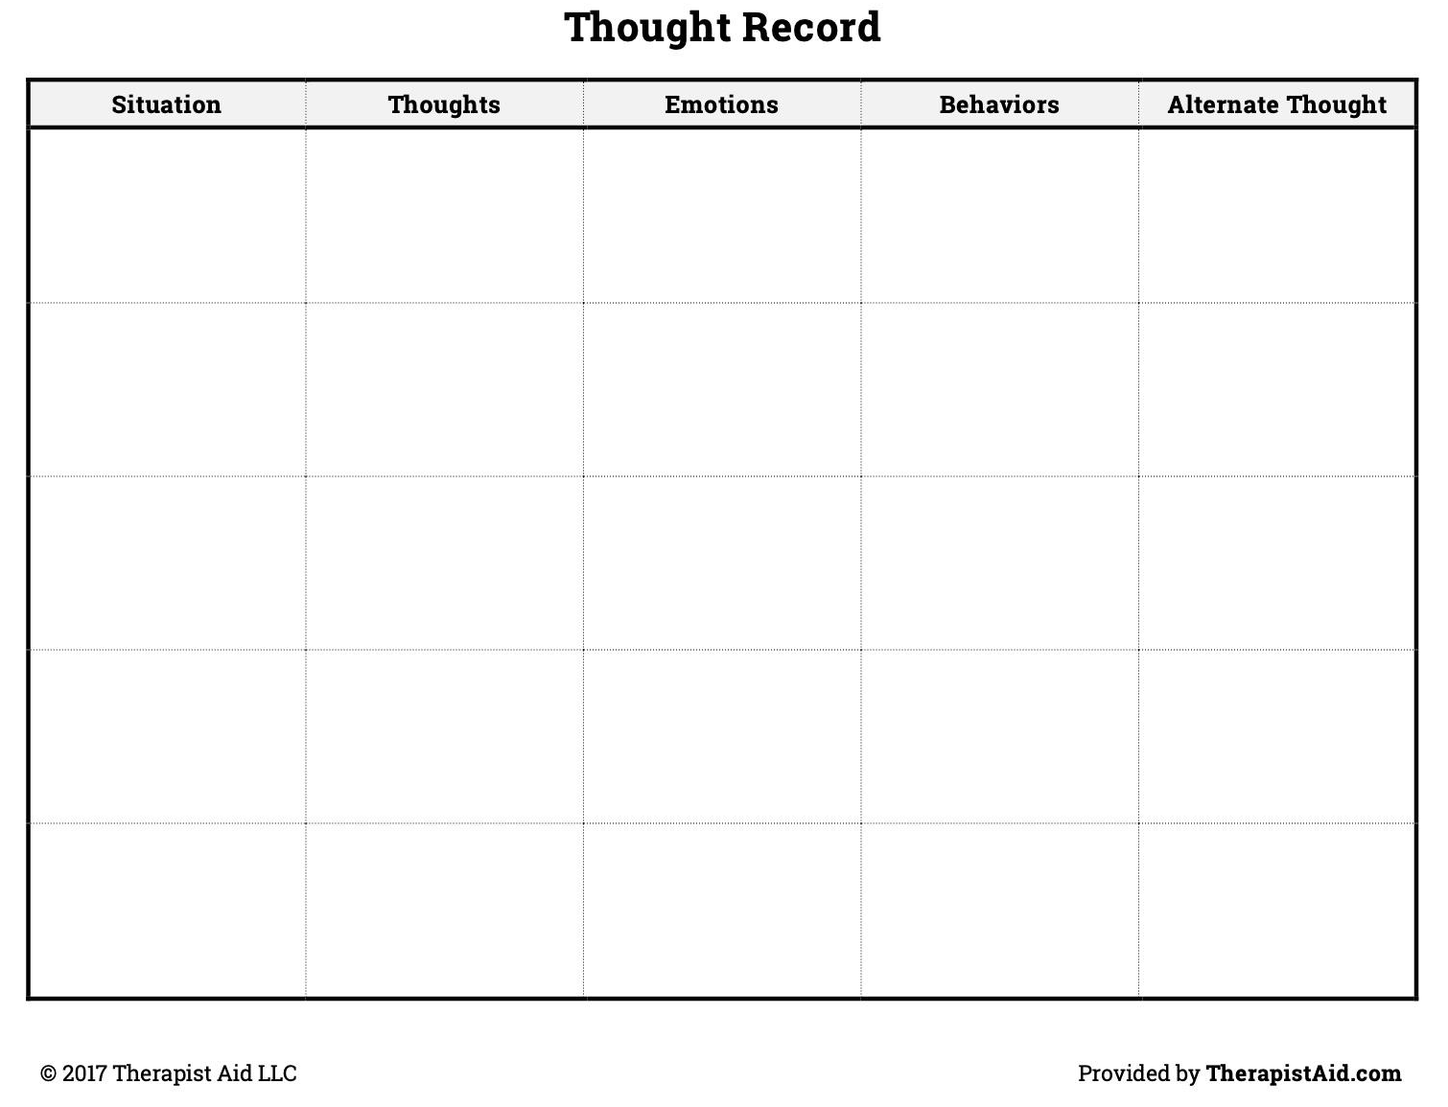

Vincent A. Lodato, LCSW, CC-AASP
Steps in Cognitive Restructuring & Positive Self-Talk

Step 1: Identify the internal dialogue (thoughts) in a specific situation that leads to excessive or unwanted anxiety, anger, worry, or fear.
Identify: A) Thoughts about yourself- confidence level
B) Thoughts about others involved
C) Thoughts about situation
Step 2: Identify any irrational ideas or feelings that might be supporting negative thinking in Step 1.
Step 3: Challenge any irrational thinking or feelings in Steps 1 and 2 by identifying:
A) What is true that you are thinking
B) What is not true that you are thinking
C) Identify any catastrophic (“what if...”), awfulized (“It would be awful if...”), or absolute (“I must, I should...”) thinking
Step 4: Substitute specific rational thoughts that don’t just reduce anxiety, anger, worry or fear. These thoughts must be directly counter to thoughts that were disruptive. They are positive, outcome oriented, and pro-active.

For example: Not just “stop worrying” or “calm down” but rather “RELAX”, “I’m in control”, and focused on what you want to accomplish, not what you don’t want to accomplish.
Chapter Four: Goal Setting & Goal Implementation
Goal setting is a common tool for motivation and direction. You have likely set your own goals before whether you realized it or not. This can look like losing weight to be in a certain weight class or aiming to land a certain strike in training. Some of these goals are seen as non-negotiables like missing weight because you compromise the ability to compete at all. Some goals are just for fun as friendly competition. Optimal performance stems from the goals you make and the strategies you apply to achieve them. To give yourself the best chance at achieving your goals, it is important to understand the what, how, when, and why.
Types of Goals
Goal setting can be classified into three types of goals that all work together: outcome, performance, and process (Weinberg & Gould, 2019). If your goal is to achieve optimal performance you must first define what optimal looks like so you know if you have achieved it. Setting a goal is best decided based on how much control you have over the outcome. Focus on the controllables. There is an assumption in full contact combat sports that we can control our opponents and if we cannot control them to win the match, it is no fault but our own. This is not for lack of effort, but for lack of control over the outcome which can involve the choices of your opponent, the referee(s), the coaches, and more. Be sure to set objective goals that are factually-based rather than subjective goals like “be better” that are personally interpreted and immeasurable.
Outcome Goals
When you set a goal that only focuses on earning a specific result like winning a match or submitting your opponent, it involves the ability and plans of your opponent (Weinberg & Gould, 2019). These goals are competitive in nature and tend to be ego-oriented and aimed at proving superiority over another compared to task-oriented, which focus on personal bests (Rares-Mihai et al., 2021). You can start with an outcome goal and work your way down. This is the end result while the other goals guide you to it. If you only focus on outcome goals, you are less likely to maintain progress on your process goals. Don’t be obsessed with the outcome.
Performance Goals
Performance goals serve as benchmarks of a performance that lead to the overall outcome goal. The standards you set for yourself are performance objectives that operate independently of others’ performances. An example would be to aim for more uppercuts or to submit from the back. These give you direction without comparing yourself to others. Achievement goal theory says that aiming to master a task and comparing yourself to your own previous performances instead of referencing someone else’s performance can improve motivation and reduce negative outcomes (Rares-Mihai et al.,, 2021).
Process Goals
Process goals or task goals are the how-to of a goal. These are the rungs of the ladder that lead you to the performance goals, which lead you to the top outcome goal. Without process goals the performance and outcome goals become less reachable. If the goal is to take your opponent down, decide the steps you can take to achieve that including set-ups, footwork, grips, entry, follow-through, plan b and c, etc. The more prepared and mapped out the route, the more likely you can get to where you’re trying to go. Focus on these goals more than any others as progress here will bring you progress in more long-term and outcome goals. These are the most controllable.
How to Set Effective Goals
How you set goals is just as important as what goals you set. Once you determine the outcome goal you have, you can map it out. If your ultimate goal is to earn a contract in the UFC, you need to break it down into achievable steps. Performance goals will be set as standards of this accomplishment such as winning as many fights as possible, winning fights in entertaining fashion, and hiring an agent. Process goals are the particulars that only you can decide for yourself such as training schedule, weight management, strategy, etc. You can use the acronym SMARTS to help guide your goal setting process (Lodato, n/d):
- Specific
  - Make your goal as specific as possible to maximize focus and direction.
- Measurable
  - Goals must be measurable or objective so you know when you achieve them. Subjective goals like “have fun” are not measurable.
- Action-oriented
  - Include what you need to do behaviorally to achieve the goal.
- Realistic
  - Goals need to be challenging, but achievable as evidenced by previous performances.
- Timely
  - Goals with reasonable deadlines are more achievable.
- Self-determined
  - The goal itself must be chosen by you.
When to Use Goals
Goals should be set according to training or competition (Weinberg & Goulds, 2019). There are steps to take in training like repetitively drilling a technique to create automated motor programs and there are goals to be met within competition like gaining control time or maintaining dominant positions. Goals can be set pre, during, and post performance to maximize optimal results by staying on track. There are also short-term and long-term goals depending on the length of time it would take to achieve them. Short-term goals are the intermediate steps for the direction of the long-term goal.
Ways to Ensure Successful Goal Setting
Record your goals using the checklist to make sure you have met each criteria for successful goal setting. It’s important that you set only one to two goals at a time because too many goals lessens the likelihood of achieving any (Lodato, n/d.). Try not to be too hard on yourself by not adjusting goals once they have been set. It is not a failure to move the goal post closer. Use your support system like coaches, trainers, teammates, family, friends to help encourage you and foster your goal commitment (Weinberg & Gould, 2019). Be sure to ask for feedback and evaluation from coaches so you can monitor your forward progress. Above all, enjoy the process.
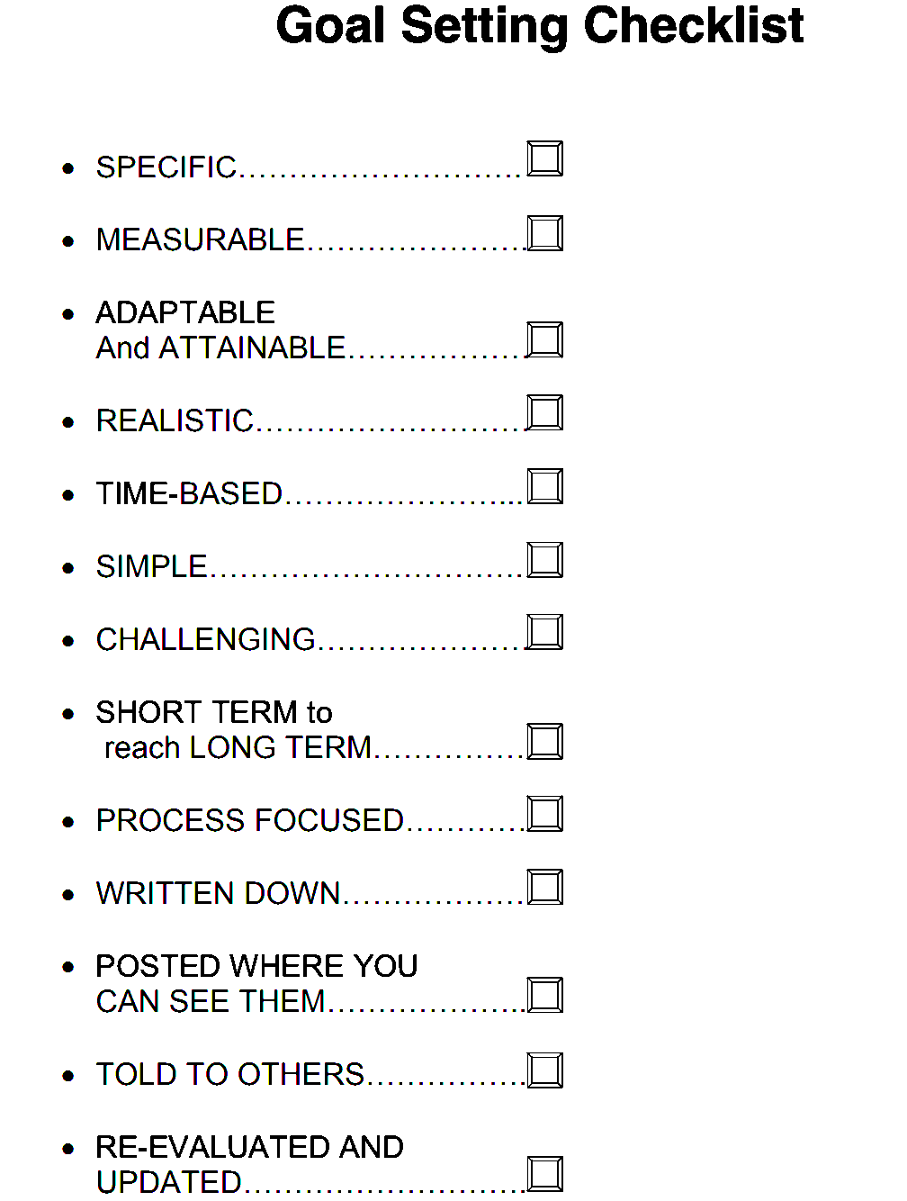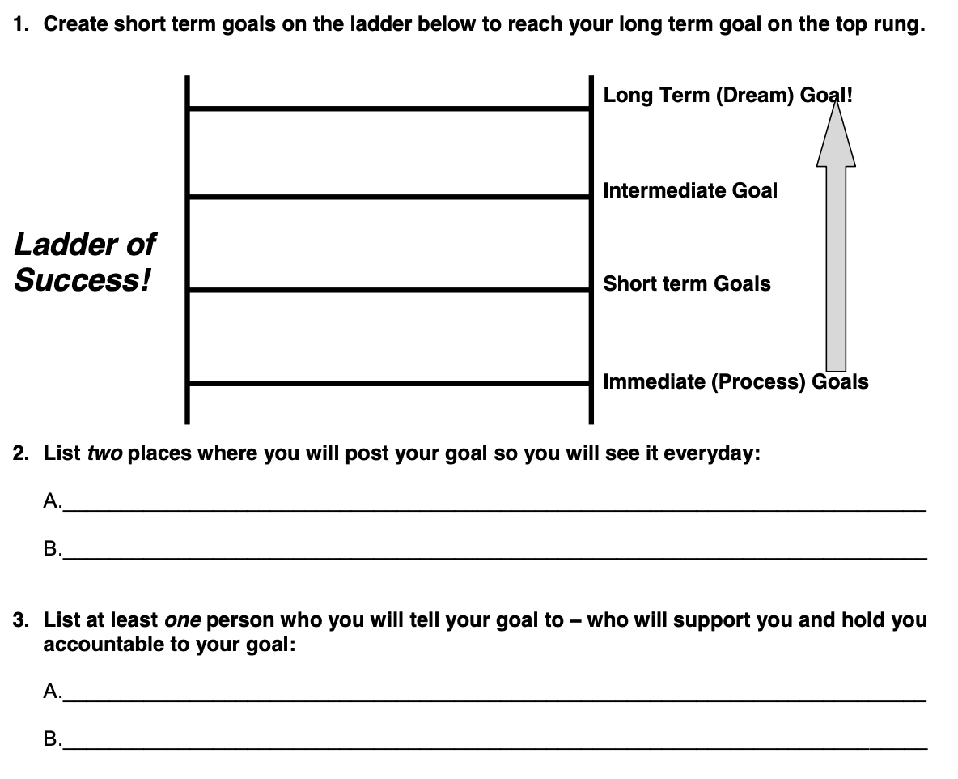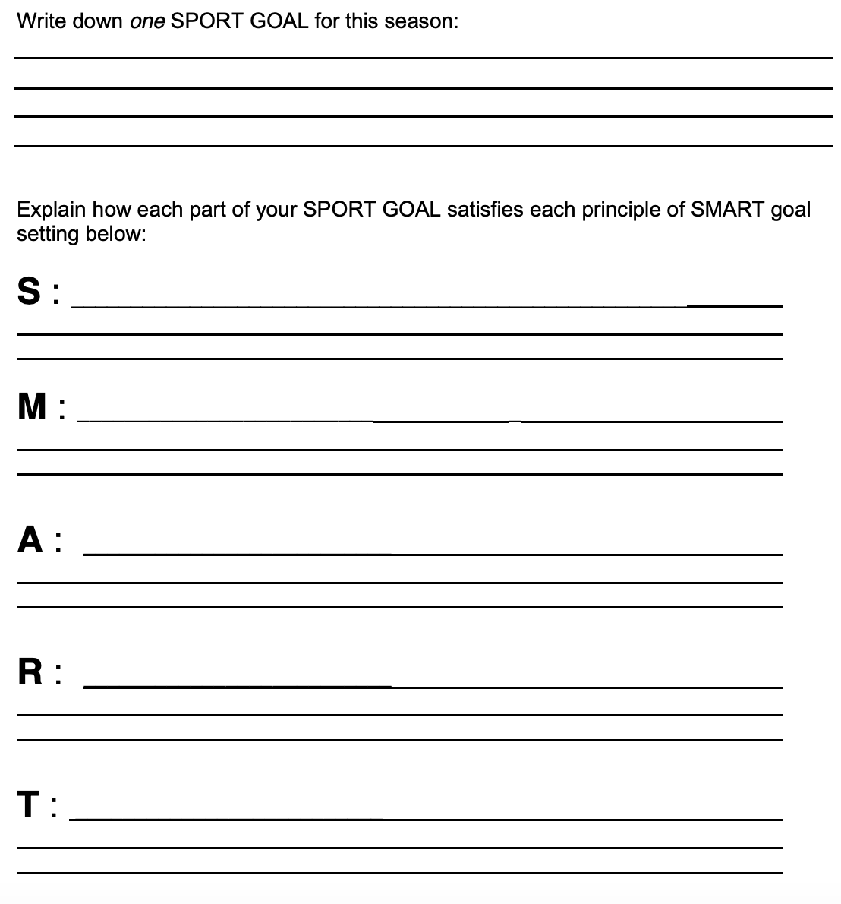

Chapter Five: Mental Toughness
Describing mental toughness is like describing love. We know it when we experience it and we can identify it in other people, yet there are no definite lists of qualities and behaviors it entails. How you show mental toughness will look different than other athletes and what matters most is how you use it to adapt and cope with stress. Fighting out of difficult positions, through exhaustion, against relentless opponents, these are all common stressors in our sport. When combat sport athletes show mental toughness, they show courage towards their fears, find strength in their weaknesses, overcome challenges that some would choose not to take on, and other heroic feats. What does that look like in the average person, though?
Mental Toughness Signs
Mental toughness looks like the small acts that allow us to get things done despite obstacles. These obstacles can be as small as spilled milk or they can be as big as a career-ending injury. How we move forward has a lot to do with our innate and learned characteristics. We all have elements or traits that can enhance mental toughness and the states or environment we are in can pull them out. That is to say, we all possess existing qualities that can develop mental toughness but I believe it must be fostered. Mental toughness is already within you and is known as your trait mental toughness and what we do with it in certain settings is our state mental toughness.
One of the models often used to break down the qualities of mental toughness is the 4C model which contains control, challenge, commitment, and confidence (Weinberg & Gould, 2019).

- Control is the ability to narrow in on what can be controlled like our own thoughts and actions rather than on what cannot be controlled like the thoughts and actions of others. This looks like choosing positive self-talk that helps to achieve your goals instead of ruminating on negative thoughts. Refer to chapter 3 for self-talk techniques.
- Challenge is the appraisal of situations as something to conquer rather than as a threat. This looks like adding a bit more weight to the bar when lifting or dusting yourself off after a failure. When you push yourself to do one more sparring round when you’re tired or enter into a big tournament that you prepare well for, this is seeking a challenge rather than avoiding a perceived threat.
- Commitment is the dedication of time and energy to worthy causes like the pursuit of excellence and avoiding distractions along the way. This looks like sacrificing instant gratification for long-term growth. Make sure you balance your life roles because athlete identity (chapter 1) is key to maintaining a healthy career.
- Confidence is the belief in yourself even in the face of failure. This looks like taking another fight after your last fight ended in a knockout loss. It means getting up after a loss and believing that you can and will achieve the goals you have set for yourself (chapter 4).
Ways to Build Mental Toughness
Athletes can build their mental toughness by practicing failure and resiliency training. Increasing the difficulty of tasks under many different threatening pressures over time can help the athlete build a plan for when they feel they are being tested. This can include positive self-talk, proper goal setting that emphasizes small process goals, and imagery tactics to visually practice a mental rehearsal plan (Vernacchia et al., 1996). You can add mental toughness routines to your routines (chapter 2).
Healthy Mental Toughness
The right amount of mental toughness is essential for maintaining a barrier against stress when striving for excellence. It can also be unhealthy if you push yourself past your limits. We know that pushing limits is important to achieving things you never had but not at the detriment of your physical and mental health. Unhealthy mental toughness can look like shame and guilt for resting instead of training, overtraining that leads to burn out or injury, and competing against others too much that ends in harsh self-judgment. Remember that to be tough is to also know when to quit. The opposite of mental toughness is not weakness, but harm so take care of yourself and strive for excellence with a mindset that protects your own welfare.
Chapter Six: Focus, Concentration, & Managing Distraction
Almost every failure in performance can be attributed to a lapse in concentration (Keegan, 2014). Attention, focus, and concentration are often used interchangeably. However this is a misunderstanding because they actually pertain to specific aspects of attentional control (Lodato, n.d.). Attention is the broad awareness of your surroundings like the beginning of a fight or match when you have to be aware of many possible cues/moves from your opponent. Focus is the ability to narrow your attention down to one or two major cues/moves like specific situations where only a few moves are used (i.e. thai clinch, back control, double-unders, etc.). Concentration is used when honing in on one skill or task like finishing an opponent with a submission or strike(s). As a combat sports athlete you use this funnel of narrow and broad attention continuously to assess new cues from your opponent, focus in on those cues, and concentrate on execution of your own moves. This is the visual-perceptual-cognitive-information processing-anticipation-decision making-reaction time-feedback loop (Lodato, n.d.).
Types of Attentional Focus
If we break down attentional focus into types, it is easier to match the appropriate focus with specific moves/situations (Weinberg & Gould, 2019). Broad attentional focus is the ability to see many things simultaneously and be sensitive to a rapidly changing situation that is a combat sports fight/match. Narrow attentional focus is the ability to respond to just one or two cues like high kicks and sweep attempts from closed guard. External attentional focus pays attention to outward variables like the opponent’s move or the loudness of the venue. Internal attentional focus pays attention to inward variables like arousal level and body mechanics. The various types can look like a narrow-external attentional focus like that which is required for slipping a punch or sprawling on a takedown attempt. A broad-internal attentional focus is sensing damage in your body or maintaining an overall calmness. A broad-external attentional focus is often used by coaches to teach how to read an opponent by focusing on the chest area with a large view so you may see all the relevant movements from many different areas of the opponent’s body. Switching between these is key to efficient attentional control just like rapidly switching from pursuing a takedown to defending a takedown is key.
What focus you use also depends on what type of skill you execute. Closed skills are those that are not affected by the environment (Weinberg & Gould, 2019). These are not often used during competition because the skills and moves we use are determined by our opponent (the environment). You use these when you drill for skill development because you can focus on the mechanics of a punch or takedown without resistance. Open skills are those that are affected by the environment. Much of combat sports involves open skills because how and when we execute a technique is influenced by what our opponent chooses to do. To see the breakdown of attentional focus types here is Nideffer’s model:
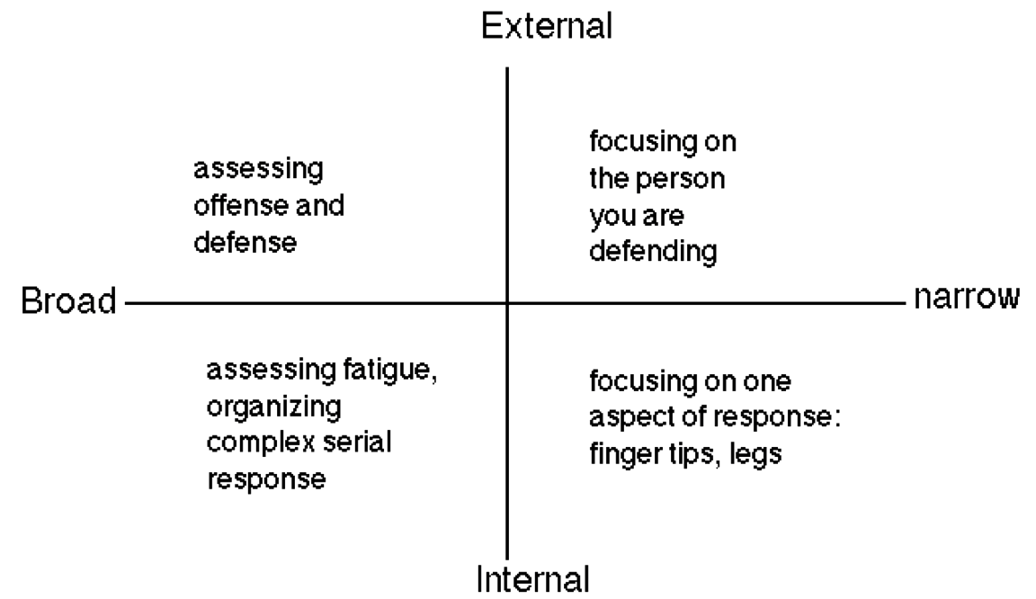

Information-Processing
The ability to read and respond to cues can be explained by the information-processing approach that says there are three processes that happen during attentional control (Weinberg & Gould, 2019). Attentional selectivity is the process of spotlighting your focus on certain cues while ignoring others. When you hone in to listen to your coach’s instructions, it is best to also screen out the opponent’s corner and the sounds of the crowds. Attentional capacity is like the gigabytes of valuable space you have for keeping attention. Everyone has a finite amount of energy to spend on attentional control and too much attention focused in the wrong places can cause fatigue (Weinberg & Gould, 2019). Attentional alertness is your level of arousal. Overarousal can cause anxiety, which can narrow your focus too much while underarousal can cause you to be too relaxed and able to respond quickly (Lodato, n.d.).
Dealing with Distractions
Concentration is difficult in a tournament setting due to the environment and nature of competing. There are two types of distractions: external and internal. It is similar to the types of focus– some are from the environment while some are from within us. Some examples:
External distractors:  - spectators  - other matches happening  - your coach/corner  - the opponent's coach/corner  - the elapsed time of the match  - score board | Internal distractors:  - adrenaline  - remembering past performances  - rumination on mistakes/outcome  - pressure to perform  - increased heart rate, sweaty palms, weak knees, heavy arms

The Performance Loop
The visual-perceptual-cognitive-information processing-anticipation-decision making-reaction time-feedback loop is an exceptionally long way of describing what happens when we read cues and respond to them (Lodato, n.d.). First you take in visual information and use perception to choose which cues are relevant. Once you evaluate this information using cognition, you use decision-making and execution to apply your response. Your fight/match is a constant loop of these processes as you continuously take in information and make rapid decisions based on that information. If you anticipate, it affects your reaction time which can be the difference between a win and a loss, safety and injury. Anticipation is affected by your arousal levels. If you are over-aroused your attentional capacity is compromised and your attentional field narrows. Too small of a spotlight can blind you of key cues and signals. If you are under-aroused, your attentional focus is broad and you may miss small cues and signals that alert you to action. Practice this loop with the following activity. Use the concentration grid to seek and circle every number from 1 to 100. This will build your attentional focus skills by switching from various cues in a broad and narrow way.

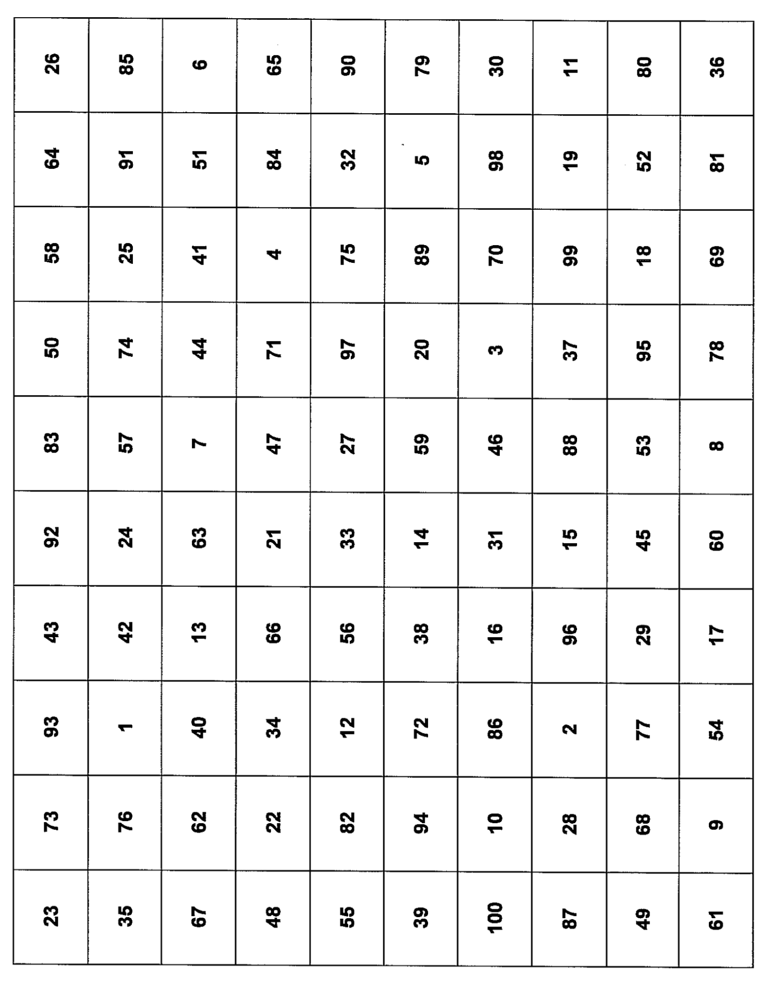

Chapter Seven: Imagery & Visualization
Imagery is the ability to create or re-create experiences in our minds (Weinberg & Gould, 2019). It is a kind of stimulation and simulation that allows athletes to visualize future images or previous memories using all five senses and imagination. Imagery is like turning your brain into a virtual reality headset. It takes time to develop imagery skills because the more vivid and controllable your imagery is, the more worthwhile it will be. There are a lot of uses including confidence, strategy, skill development, and more. If you like to daydream, imagery may be a great mental skill to incorporate into your training.
Why Use Imagery?
Have you ever visualized a scenario in your head about what could happen on fight day or how it will feel to win a world title? There are two ways to use imagery to your benefit: cognitive and motivational. Cognitive imagery is used for planning out strategies and developing skills (Weinberg & Gould, 2019). Your cognitions are your thoughts and what you imagine will be affected by these thoughts such as what the venue will look like on fight day, how to respond to a bad weight cut, or what techniques you will use to take your fight to the ground. It is the decision-making process that comes with competing against an opponent in combat sports as well as the process of turning your techniques into “muscle memory”.
Motivational imagery is used to visualize specific goals and behaviors that help you achieve those goals. If your goal is to win a world title, it can be helpful to imagine yourself finishing the match, seeing the crowd cheer your name, feeling the moment as if it were real. This can help when you lack the motivation to do the boring, hard things that bring you to success like meal prepping your food or running on the treadmill. You can also use this imagery to activate your arousal whether you need to relax because you are feeling too anxious before a match, or you need to hype yourself up for a training session.
There are 5 types of motivational and cognitive imagery for different functions (Weinberg & Gould):
Motivational-General (MG)  Mastery (MG-M) uses imagery for effective coping and confidence.  Arousal (MG-A) uses imagery for relaxation/ energization to either calm down or get hyped | Cognitive-General (CG)  Uses imagery to rehearse game plans and strategies like imagining the beginning of a jiu jitsu match or the first round of a fight.
Motivational-Specific (MS)  Uses imagery for specific goals and goal-oriented behaviors, such as winning a fight or earning a TKO finish. | Cognitive-Specific (CS)  Uses imagery to rehearse techniques and fine-tine movements or correct errors like imagining the mechanics of a specific combo.
What Makes Imagery Effective?
There are five characteristics of imagery that determine how effective it will be:
- Modality: Use all of your senses. This includes what you can see (visual sense), how your body feels as it moves (kinesthetic sense), what you can hear (auditory sense), what you can smell (olfactory sense), and how something feels to touch (tactile sense).
- Perspective: Are you viewing your imagery from the internal perspective as in your own point-of-view (POV) or are you viewing yourself externally as a spectator? Are you in the ring or are you watching yourself from the VIP section?
- Angle: If you have an external perspective, from what direction are you viewing yourself? This could be from above, from behind, from below, etc.
- Deliberation: Is your imagery deliberate or spontaneous?
- Agency: Who is the author or director of the image? You or someone else?
How it Works
There are multiple theories to explain the effectiveness of imagery. The psychoneuromuscular theory is that when you imagine certain events like performing a takedown or completing a combo, your neural pathways respond as if you are actually doing that move. It is as if your muscles don’t know the difference. This is very important for combat sports where repetition of movements and techniques are required for use in sparring. Drilling a move is time consuming and exhausting, so imagine getting your repetitions in from the comfort of your bed. Symbolic learning theory is also important for combat sports athletes because it allows imagery to be used as a way to strategize through a coding system that helps you understand and acquire movement patterns (Weinberg & Gould, 2019). Many motor programs like finishing a single leg takedown or defending a right hook are dependent upon the opponent’s moves. Imagery can be used to combine the motor skills (your physical techniques) with the cognitive components (deciding which move and when to use it).
Similarly, bioinformational theory divides an image into two parts: stimulus proposition and response proposition. Practicing a sprawl or footwork is the stimulus while imaging how the opponent will attack or defend is the response.The triple code theory states that three things happen during the imagery process. First, you create an image that allows you to interact with it as if it were the outside world (Weinberg & Gould, 2019). Then, there is a somatic response, the way you react to the image and the physiological changes that happen to your body in response to the imagined experience. This could be an elevated heart rate, slowed breathing, sweaty palms, etc. The last part is the meaning of the image and its significance to the goal of your imagery.
Ways to Build Imagery Skills
Everyone will have different experiences with imagery and no two experiences will be the same. Some will see themselves on a movie screen while others will be in first-person perspective (Lodato, 2016). It is best to start small. Start by sitting in a comfortable position with your eyes closed and think about your bedroom. Can you visualize your bed, the color of your walls, what objects are on your bedside table, the art on the walls, the cleanliness or messiness of it? What does it smell like? Do you feel a sense of calm being in your own home? How does it feel to sit on your bed–is it firm or soft? By recreating familiar territories in your mind, you can practice the vividness and controllability of your images. It can help to hold props as well or wear your fight uniform. Put on your gi or your gloves, and give it a try!

Chapter Eight: Performance States
How you deal with stress determines a lot about your experience as an athlete. Combat sports are intense, requiring fighters to manage their energy and activation levels throughout a fight or match. There is no optimal level of arousal for what we do but rather an optimal arousal level according to your personality, your perception of stress, as well as your psychological and psychological responses to stressors. How can we identify and reach these optimal arousal levels then?
Arousal Versus Anxiety
Arousal and anxiety are factors that make a difference in performance levels through how they affect your attention (Weinberg & Gould, 2019). How aroused you are pertains to how activated you are mentally and physically at any moment in time. Some tasks, like folding laundry, require very little arousal. Other tasks, like fighting an opponent in a boxing match, require quite a bit of arousal. Anxiety is the negative emotion characterized by nervousness, worry, and apprehension and is associated with arousal. When you begin to ruminate over the what ifs and potential negative outcomes, you are feeling state anxiety. The mental aspect (worry, intrusive thoughts, etc) is called cognitive anxiety while the physical aspect (increased heart/breathing rate, sweating, etc.) is called somatic anxiety. The difference between trait and state anxiety is important, too. Trait anxiety is part of your personality and can be seen as a predisposition for state anxiety, which everyone experiences. State anxiety is the ever-changing mood aspect. The beginning of a fight may bring nerves but when you secure a dominant position those nerves will likely subside.
Stress and Its Sources
We all know what it feels like to be stressed. Stress is defined as an imbalance between resources and demand where failure to meet a certain outcome has important consequences (Lodato, n.d.). Facing adversity is a normal part of life and of combat sports so how you react to that adversity can be dependent on your level of mental toughness (chapter 5). There are so many stressors involved with being a combat sports athlete like pressure to perform, dealing with loss, facing a tough opponent, having self-doubts. It is helpful to narrow stress down to two types of sources: situational and personal. Situational stressors are those that come from importance placed on an outcome and personal stressors depend on your personality traits and whether or not you are susceptible to greater anxiety (Weinberg & Gould, 2019).
Situational:  - importance of event  - uncertainty of outcome | Personal:  - presence of trait anxiety  - self-esteem levels  - social anxiety from others observing your physique

There are four stages in the stress process (Weinberg & Gould, 2019):
- 1. Environmental Demand: Physical or psychological demand placed on you like a deadline or a heavy weight.
- 2. Perception of Demand: The meaning you place on the demand which will be different for every person. The more trait anxiety you have, the more likely you are to perceive a demand as threatening.
- 3. Stress Response: If you perceive there is an imbalance between your resources and the demand, you experience physical and psychological responses like elevated heart rate and increased worrying.
- 4. Behavioral Consequences: How you react to your perception and if you believe the demand is beyond your resources will determine how you perform. Do you do better under pressure and perceive it as a challenge or do you feel threatened and performance suffers?
Effects on Performance
How does this affect your performance? Picture arousal as a scale from one to ten where one is asleep and ten is panicked. Drive Theory was the first to explain a relationship between arousal performance by saying when a person’s arousal or state anxiety increases, so too does their performance. The Inverted U Hypothesis describes optimal arousal levels as a range that allows for optimal performance. Outside of this range is underarousal when you feel sluggish and unable to respond to stimuli quickly and overarousal when you feel too overwhelmed or anxious to function properly. Your attention span (chapter 6) becomes either too broad or too narrow, and you miss relevant cues and signals. Sprawling in defense of a takedown is ineffective and can be dangerous if done too late or too soon. Everyone has a unique optimal arousal level based on your levels of trait and state anxiety. This is known as your Individualized Zones of Optimal Functioning or IZOF. Then there is Reversal Theory, which says that arousal is up to interpretation and that you can actually switch your feeling towards your arousal/anxiety from negative (fear) to positive (excitement). It’s like your brain doesn’t know the difference! Multidimensional Anxiety Theory adds that just cognitive state anxiety like worrying thoughts is the culprit for negative performances. The Catastrophe Model stands by the Inverted-U Hypothesis but only when it doesn’t involve cognitive state anxiety. When there is worrying, it escalates until a threshold or catastrophe and performance suffers a rapid decline.
Jones' model of facilitative and debilitative anxiety shows that when an environmental stress happens, like when you are about to enter the cage or start a match, your perception of control can help determine whether it will be facilitative (helpful) or debilitative (harmful) to performance.You can use this information to understand that stressors can be categorized based on how much control you feel that you have. It is important to remember that you can control your own movements but you cannot control your opponents'. In other words, you can influence the level of your opponent's performance, but you cannot orchestrate it (Casstevens & Mack, 2001). This is a big source of power when you can identify what you can and cannot control.
Overall, it is important to understand your optimal arousal levels, how to reach them, and how you interpret them. Anxiety is anticipatory meaning it builds prior to a perceived stress (Lodato, n.d.) Getting a hold of anxiety is a complex skill but understanding what it is can help in identifying how it affects your performance. Appraisal is an important aspect of stress as well so how you perceive a stressor determines the physiological response.
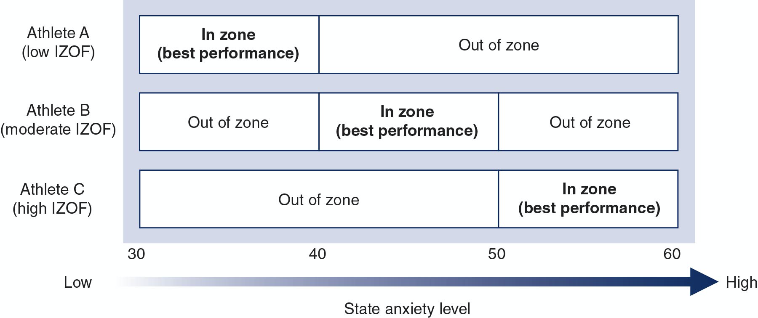

Chapter Nine: Handling Performance Errors & Setbacks
Errors and setbacks are unavoidable in sports. Think about your past performances. Was there a time that you did not use the right technique at the right time? Have you ever tapped out before? Of course and that’s okay because it is part of the learning process. This process of being introduced to techniques, implementing those techniques into your game, and then applying them in real-time sparring is bound to produce errors. That’s what training is for! How we cope with those errors determines whether we learn from them and move forward or set ourselves up for more errors.
Get Comfortable with the Uncomfortable
Full-contact combat sports can be uncomfortable from day one. As a fighter it is common to focus on making your opponent uncomfortable. We know that experiencing anxiety or mental fatigue makes it hard to be present and focused with the right timing. This increases the chance of mistakes, which is common (Weinberg & Gould, 2019). This means you are fighting against someone who is attempting to do the same to you--throw you out of the fight. There are critical errors (getting knocked out or submitted) and routine errors (missing a punch, forgetting to check a kick, not stuffing a takedown) and both should be managed in order to stay in the fight.
Every athlete makes mistakes and every fighter experiences loss. In jiu jitsu we like to say, "you either win or you learn" because there is a lesson in every match, round, or fight that can be used for growth. Anyone who chooses to put their training on the line and face the possibility of loss should know that mistakes are not set backs but opportunities for improvement. When we experience errors then, having a pre-practiced routine (chapter 2) can help to get over the error and move forward (Weinberg & Gould, 2019).

Problem-Focused Versus Emotion-Focused Coping
Coping with adversity is the way in which you appraise a situation and if the demands exceed your resources (Weinberg & Gould, 2019). There are two categories of coping: problem-focused and emotion-focused. Problem-focused coping strategies are used when the situation is changeable. If you can manage the problem that is causing the stress, you can deal with the stressor itself. You can do this by having pre-fight strategies and routines, managing your time, gathering information, and using mental training skills like goal-setting and self-talk. Emotion-focused coping strategies are employed when the problem or situation cannot be changed. This involves regulating your emotional response to the stressor. You can do this through mindfulness meditation, relaxation techniques, reappraising the meaning of the stressor, or even withdrawal. It is important to include identification of which coping strategy is appropriate for each situation when working on a routine for dealing with adversity.
Guidelines to Managing Errors and Setbacks
- Be in the moment and present. Replaying errors or anticipating future situations produces anxiety, which narrows attentional focus (chapter 6) and makes it hard to read important cues from your opponents. Practicing mindfulness techniques can be key to remaining in the fight and freeing up mental capacity for decision-making.
- Recognize the warning signs of tension. We all have certain symptoms of anxiety or stress that are noticeable. Raising awareness of these signs allows the ability to manage it. Less tension means less errors.
- Have fun. If you don't enjoy what you do, motivation, arousal, concentration and more can be compromised. It also might cause an overemphasis on outcomes, which increases anxiety (Weinberg & Gould, 2019).
- Come with a good game plan. Fighters make decisions over and over again. Should I jab or hook? Should I secure the arm or go for the choke? Oh there's an uppercut I have to dodge! Lessening the decision-making in the moment by having a strategy with your A-game and some plan C's or B's can reduce errors.
- Don't rush. It can be tempting to just get the thing over with if you feel you are making errors. Try to slow down rather than racing through, which causes more errors.
Building Personalized Routines
Most fighters have rounds with a minute rest in between for coaches to talk with the athlete and some have matches that go all the way through. This means you will have to practice your routines well since it will be self-activated most of the time. It also means the routines have to be quick (Lodato, n.d.). Some things you can add are: diaphragmatic breathing, symbolic reset after an error, positive/instructional self talk (chapter 3), cognitive reappraisal, strategy planning, arousal management techniques (chapter 8).
Sample Routine
You've just been taken down in a fight that you wanted to keep on the feet. Manage your breath with big belly breaths with the thought "I got this" on the inhale and "I am good anywhere" on the exhale. Wipe away the error with your hand or glove on your face or the mat, focus on the next technique and move forward.

Chapter Ten: Technology & Tools for MST
Technology can be a huge aid in mental skills training. Whether you use your social media to stay connected with your biggest social support to reduce stress or record your self-talk scripts on your voice memos application, technology has a way of seamlessly integrating into our lives. It’s important to assess why you should use a certain tool, what you want to measure, how it will benefit you, if it translates to performance, the validity and reliability of its data, and the privacy settings.
Is it Useful?
In chapter 7 I used virtual reality (VR) technology as an analogy for imagery and the skills necessary for vivid and therefore effective outcomes. Apps can be used to facilitate motivation, commitment, education, data recording, neurofeedback, biofeedback, and more. How do we know if it translates to your performances? Can a videogame train a fighter to manage his/her/their emotions under pressure? Can a heart rate tracker improve your cardio during a match? These are questions you will have to ask regarding any technology you implement into your routine. Many products can give you information regarding your basic vitals like weight, breathing rate, heart rate, pulse, blood oxygen level, temperature, etc. Some apps can use that information and interpret it for your benefit. Whether it translates to your performance is dependent upon each step in the process of data collection and interpretation is error-free.
Assessing Validity and Reliability
There are a lot of products and apps out there so how do you know which ones are valid and reliable? Nutrition apps like MyFitnessPal will take the specs of your self-reported food intake and interpret what you are missing from your diet but it relies on your initial input. Now we must consider the reliability of your initial information as well as the algorithm the app uses to interpret your results. A framework by Windt et al. (2020) for deciding whether to use a certain technology to aid your athletic performance consists of four questions to ask yourself:
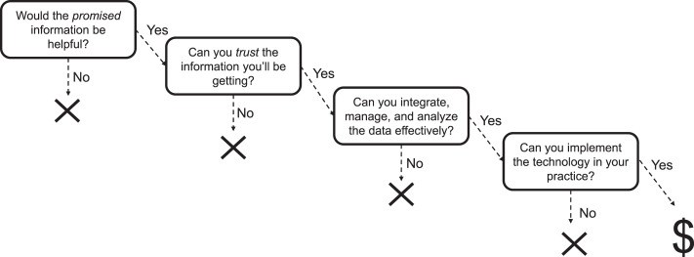
- Would the promised information be helpful? Start with the end in mind. What are you trying to measure and/or achieve? What question are you trying to solve and/or what need are you trying to fill?
- Can you trust the information you’ll be getting? You can gain trust by reviewing existing literature that has not been paid for by the product company itself. Look for peer-reviewed studies with the technology proving its validity.
- Can you integrate, manage, and analyze the data effectively? Many products and apps have user interfaces that make learning how to use the data easy. This does not ensure that the data is managed effectively, however. As a consumer you have limited knowledge of data evaluation but trusting a product often means trusting its data.
- Can you implement the technology in your practice? Consider the time and resources required to use the technology and how that interferes with your current routine. If a technology is burdensome, does it still provide beneficial outcomes?

Ethical Considerations
What happens when information is available without proper education and training to understand it? Information, then, becomes something that must be used carefully. In order to make sure that whatever tools you use will aid your performance, you must be aware of the ethical issues involved. It may be obvious but make sure you are not harmed or experience discomfort. What are the possible negative outcomes in using this technology? Do you understand how to troubleshoot if there are errors or issues?
Confidentiality is a concern with technology because when we use a third-party app or program, there are often specific privacy settings that must be maintained. Does the app send data to third parties? How is data stored? Who can access the information? Informed consent is also very important when using technology because technology is always changing. Just because you understand one heart monitoring app does not mean you understand the other ten available programs in the app store. Competency is important so that you can be well-informed of the process, results, situations, and other aspects you will be exposed to. You should understand all involved and make your own determination if the benefits of the technology seem appropriate and reliable to meeting your needs.

References
Andrade, A., Dominski, F.H. & Andreato, L.V. (2021). Many medals, but few interventions: The paradox of sports psychology research and Olympic combat sports. Sport Sciences for Health, 17, 481–485. https://doi-org.uws.idm.oclc.org/10.1007/s11332-021-00733-y
Casstevens, D. & Mack, G. (2001). Mind gym: An athlete’s guide to inner excellence. New York, NY: McGraw Hill.
Giannone, Z. A, Haney, C. J., Kealy, D., & Ogrodniczuk, J. S. (2017). Athletic identity and psychiatric symptoms following retirement from varsity sports. Journal of International Social Psychiatry, 63(7), 5-8-601. doi: 10.1177/0020764017724184
Hazell, J., Cotterill, S. T., & Hill, D. M. (2014) An exploration of pre-performance routines, self-efficacy, anxiety and performance in semi-professional soccer. European Journal of Sport Science, 14(6), 603-610.
Hughes, R., & Coakley, J. (1991). Positive deviance among athletes: The implications of overconformity to the sport ethic. Sociology of Sport Journal, 8(4), 307-325.
Keegan, R. (2014). Concentration and focus in sport and performance psychology. (2014). Youtube.
Lodato, V. (2016). Week 2 being prepared: Routines for readiness [Video]. Panopto.
Lodato, V. A. (n/d). Week 3: Self-Talk [Video]. Panopto.
Lodato, V. A. (n/d). Week 4 goal setting [PowerPoint slides]. University of Western States.
Lodato, V. A. (n/d). Week 5 Mental toughness, coping with adversity and resiliency. [PowerPoint slides]. University of Western States.
Lodato, V. A. (n.d.). Week 6 Mental focus, concentration and distraction. [PowerPoint slides]. University of Western States.
Lodato, V. A. (n.d.). Week 7 Imagery and visualization. [PowerPoint slides]. University of Western States.
Lodato, V. (2016). Week 7: Imagery [Video]. Panopto.
Lodato, V. A. (n.d.). Week 8 performance states. [PowerPoint slides]. University of Western States.
Lodato, V. A. (n.d.). Week 9 Handling performance errors and setbacks. [PowerPoint slides]. University of Western States.
Orlick, T. (2016). In pursuit of excellence: How to win in sport and life through mental training. (5th ed.). Champaign, IL: Human Kinetics.
Rares-Mihai, P., Florina, G., E., & Alexandru, Z. (2021).A systematic review of goal setting interventions to improve sport performance. Studia Ubb Educatio Artis Gymn, 1, 35-50. Doi: 10.24193/subbeag.66(1).04.
Vernacchia, R. A., McGuire, R.T., & Cook, D.L. (1996). Coaching mental excellence: It does matter whether you win or lose. Palo Alto, CA: Warde Publishers.
Weinberg, R.S., & Gould, D. (2019). Foundations of sport and exercise psychology (7th ed.). Champaign, IL: Human Kinetics.
Windt, J., MacDonald, K., Taylor, D., Zumbo, B. D., Sporer, B. C., & Martin, D. T. (2020). "To tech or not to tech?" A critical decision-making framework for implementing technology in sport. Journal of Athletic Training, 55(9), 902–910. https://doi.org/10.4085/1062-6050-0540.19

